**PATIENT TRACKER**

**Application Design**

**V1.0**

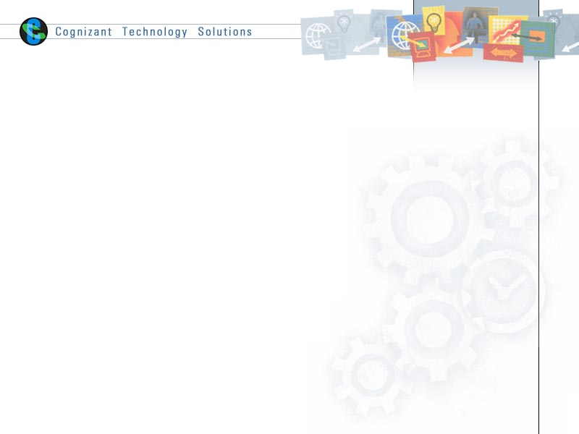

|  |  |  |  |  |  |  |
| --- | --- | --- | --- | --- | --- | --- |
| **S.no** | **Prepared By** | **ROLE** | **SIGNATURE** | **Date** | **Reviewed by** | **Approved By** |
| **1.** | RAGHUPATHI KANNAPURAM | Team Leader | Raghupathi Kannapuram | 4/2/2015 | Project Leader/ Team Leader/ Team Member | Project Manager/ Team Leader |
| **2.** | YASHWANTH REDDY PATLOLLA | Team member | Yashwanth Reddy | 4/2/2015 | Project Leader/ Team Leader/ Team Member | Project Manager/ Team Leader |
| **3.** | ADAPA RAJU | Team member | Raju | 4/2/2015 | Project Leader/ Team Leader/ Team Member | Project Manager/ Team Leader |
| **4.** | IMMADI SAI TEJA | Team member | Sai Teja | 4/2/2015 | Project Leader/ Team Leader/ Team Member | Project Manager/ Team Leader |
| **5.** | SONAKSHIBANIK | Team member | SonakshiBanik | 4/2/2015 | Project Leader/ Team Leader/ Team Member | Project Manager/ Team Leader |

# Introduction

## Purpose of this document

The detailed design contains the design of every module / sub-system. This covers the following:

* Design of common / generic components
* Module / Sub-system design
* Unit / Class / Program Specifications

From a content consideration, the above three have been combined in this document. However depending on the scale of design or projects, from manageability and configurability point of view, the above three may be split and maintained

## Scope

* Create and maintain clerk information.
* Create and maintain doctor information
* Create and maintain patient information.
* Create and maintain medicine information
* Create Prescription for patients.
* Create Bill for Patients.

## Intended Audience

The intended audience for this document is

* Developers, testers, other associates in the project
* Client
* Delivery Assurance Group, Process Engineering group

# Conventions and Standards Followed



# Assumptions, Dependencies and Risks

* Once the application is built the PATIENT TRACKER will manually load the current Clerk and Doctor list into the system.
* Clerk, Patient and Doctor are users for the application. The profiles will be maintained by the Clerk.
* Any changes to the design mentioned in the BRD would be taken as a Change Request.

# Object Descriptions

### Login Page

### Functional Requirement

Login Page checks the authentication of the user and based on his role, directs the user to the respective page. Admin will provided with Registering patient, Registering Doctor and Add medicine pages while the end user will allowed to User Regulation Report and User Regulation page.

### UI Controls

|  |  |  |  |  |
| --- | --- | --- | --- | --- |
| **#** | **UI Component** | **Type** | **Name** | **Details** |
| 1 | Login Control | LoginControl | LoginControl | Allows the clerk/doctor to login to the patient tracking portal. |

### UI Methods Definition

|  |  |  |
| --- | --- | --- |
| **Method Name** | **Parameter** | **Details** |
| Page_Load | None | Loads the Login page |
| LoginControl_Authenticate | object sender, AuthenticateEventArgs e | Allows user to redirect to the required page based on the role |

### UI Design

Home page

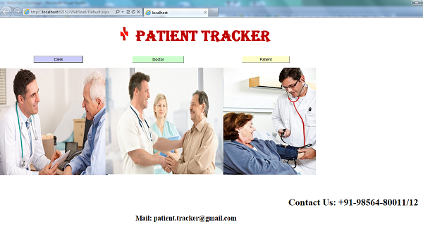

### UI Controls

|  |  |  |  |  |
| --- | --- | --- | --- | --- |
| **#** | **UI Component** | **Type** | **Name** | **Details** |
| 1 | Clerk | Label | lbl_clerk |  |
| 2 | UserId | Label | lbl_clerkusrid |  |
| 3 | UserId | Textbox | txt_clerkusrid | Get the username details of the clerk |
| 4 | Password | Label | lbl_clerkpswrd |  |
| 5 | Password | Textbox | txt_clerkpswrd | Gets the password of clerk |
| 6 | Log In | Button | btn_clerk_login | To log in |
| 7 | Doctor | Label | lbl _doctor |  |
| 8 | UserId | Label | lbl _doctor_usrid |  |
| 9 | UserId | Textbox | txt_doctor_usrid | Get the username details of the doctor |
| 10 | Password | Label | lbl_doctor_pswrd |  |
| 11 | Password | Textbox | txt_doctor_pswrd | Gets the password of doctor |
| 12 | Log In | Button | btn_doctor_login | To log in |
| 13 | New clerk Registration | Button | btn_clerk_reg | To add new clerk |
| 14 | Reset | Button | btn_reset | Clear all the fields |

### UI EVENT DEFINITIONS

|  |  |  |
| --- | --- | --- |
| **Event** | **Control/Component** | **Event Details** |
| ClerkLoginBtn_Click | ClerkLoginButton | Loads the clerk login Page. |
| DoctorLoginBtn_Click | DoctorLoginButton | Loads the doctor login page. |
| RegisterationClerkBtn_Click | NewClerkButton | Loads the clerk registration page. |
| HomeBtn_Click | HomeButton | Reverts back to the home page. |

### Panel DESIGN

Clerk Login Panel

UI DESIGN

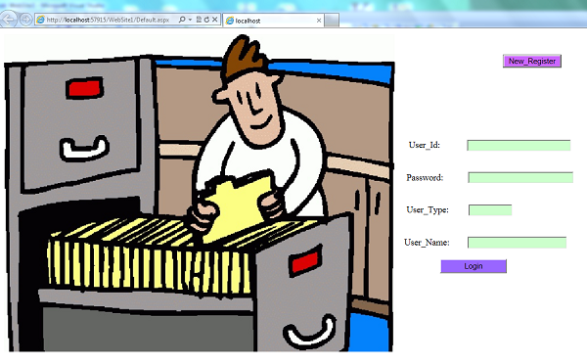

UI CONTROL

|  |  |  |  |  |
| --- | --- | --- | --- | --- |
| **#** | **UI Component** | **Type** | **Name** | **Details** |
| 1 | REGISTERING PATIENT | Menu Strip | menu_strip_reg_patient | Reverts to patient registering page |
| 2 | REGISTERING DOCTOR | Menu Strip | menu_strip_reg_doc | Reverts to doctor registering page |
| 3 | MEDICINE INVENTORY | Menu Strip | menu_strip_med | Reverts to adding medicine details page |
| 4 | HOME | Menu Strip | menu_strip_home | Reverts back to home page |

UI EVENTS DEFINITION

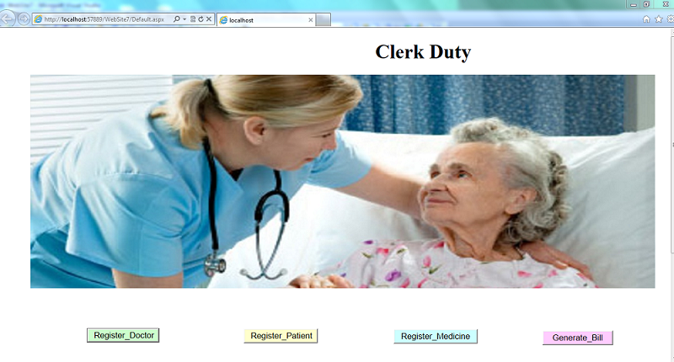

|  |  |  |
| --- | --- | --- |
| **Event** | **Control/Component** | **Event Details** |
| PatientRegistrationBtn_Click | RegisterPatientButton | Loads the patient registration page. |
| DoctorRegistrationBtn_Click | RegisterDoctorButton | Loads the doctor registration page. |
| MedicineInventoryBtn_Click | AddMedicineButton | Loads the add medicine page. |
| Generate_bill | Gen_btn | Generates the total bill of the patient |

Patient registration

UI DESIGN



UI CONTROLS

|  |  |  |  |  |
| --- | --- | --- | --- | --- |
| **#** | **UI Component** | **Type** | **Name** | **Details** |
| 1 | Name | Label | lbl_name |  |
| 2 | Name | Textbox | txt_name | Gets the patient name |
| 3 | Age | label | lbl_age |  |
| 4 | Age | Textbox | txt_age | Gets the patient age |
| 5 | Gender | Dropdown list | ddl_gender | Gets the gender of the patient |
| 6 | Address | label | lbl_Address |  |
| 7 | Address | textbox | txt_Address | Gets the address of the patient |
| 9 | country | label | lbl_Country |  |
| 10 | country | Combo box | comboBox_Country | gets the country of the patient |
| 11 | state | label | lbl_State |  |
| 12 | state | Combo box | comboBox_State | gets the state of the patient |
| 13 | city | label | lbl_City |  |
| 14 | city | textbox | txt_City | Gets the city of the patient |
| 15 | Email ID | label | lbl_EmailID |  |
| 16 | Email ID | textbox | txt_EmailID | Gets the email id of the patient |
| 17 | Contact Number | label | lbl_Contact |  |
| 18 | Contact Number | textbox | txt_Contact | Gets the contact number of the patient |
| 19 | Submit | button | btn_submit | To submit the details of the patient |
| 20 | Reset | button | btn_reset | To clear all the fields |
| 21 | Patient Id | Data grid view | Data_grid_view_patient | Display the patient Id |

UI METHODS

|  |  |  |
| --- | --- | --- |
| **Method Name** | **Parameter** | **Details** |
| ValidateName | Name | Check if the name contains only alphabets and spaces. |
| ValidateContactNum | Contact Number | Check if the number is only numeric |
| ValidateEmailId | Email ID | Check if the format of id is correct or not |
| ValidatePatientAge | Age | Check if the age is more than 0 |
| BindCountryName | None | Binds the country names to the combobox. |
| BindStateName | None | Binds the state names to the combobox |
| BindCityName | None | Binds the city names to the combobox |
| Binddata() | None | Binds the patient Id to Data_grid_view_patient gridview |
| ValidateMandatory | None | Check all the not null columns are filled properly |

UI Event definition

|  |  |  |
| --- | --- | --- |
| **Event** | **Control/Component** | **Event Details** |
| On Load | Page | Load the country, city, state, values to the combobox |
| submitPatientBtn_Click | submitPatientButton | Adds patient details to the Database. |
| clearPatientBtn_Click | clearPatientButton | Clears patient’s details from the page. |

Doctor registration

UI DESIGN

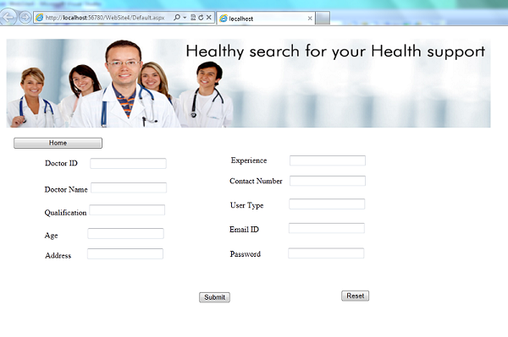

UI CONTROL

|  |  |  |  |  |
| --- | --- | --- | --- | --- |
| **#** | **UI Component** | **Type** | **Name** | **Details** |
| 1 | Name | Label | lbl_name |  |
| 2 | Name | Textbox | txt_name | Gets the doctor name |
| 3 | Age | label | lbl_age |  |
| 4 | Age | textBox | txt_age | Gets the doctor age |
| 5 | Qualification | label | lbl_qual |  |
| 6 | Qualification | textBox | Txt_qual | Gets the doctor’s qualification |
| 7 | Gender | label | lbl_gender | Gets the gender of the doctor |
| 8 | Experience | label | lbl_exp |  |
| 9 | Experience | textBox | txt_exp | Gets the Doctor Experience |
| 10 | Address | label | lbl_Address |  |
| 11 | Address | textbox | txt_Address | Gets the address of the doctor |
| 12 | country | label | lbl_Country |  |
| 13 | country | Combo box | comboBox_Country | gets the country of the doctor |
| 14 | state | label | lbl_State |  |
| 15 | state | Combo box | comboBox_State | gets the state of the doctor |
| 16 | city | label | lbl_City |  |
| 17 | city | textbox | txt_City | Gets the city of the doctor |
| 18 | Pincode | label | lbl_Pincode |  |
| 19 | Pincode | textbox | txt_Pincode | Gets the pin code of the doctor |
| 20 | Email ID | label | lbl_EmailID |  |
| 21 | Email ID | textbox | txt_EmailID | Gets the email id of the doctor |
| 22 | Contact Number | label | lbl_Contact |  |
| 23 | Contact Number | textbox | txt_Contact | Gets the contact number of the doctor |
| 24 | User type | label | Lbl_usertype |  |
| 25 | User type | Combo box | comboBox_usertype | Default value ‘Doctor’ |
| 26 | Submit | button | btn_submit | To submit the details of the doctor |
| 27 | clear | button | btn_clear | To clear all the fields |
| 28 | All the fields are Mandatory | label | lbl_mandatory |  |
| 29 | Login credentials of Doctor | Data grid view | Data_grid_view_doc | Display the login credentials of the doctor(doctor Id and password) |

UI METHODS

|  |  |  |
| --- | --- | --- |
| **Method Name** | **Parameter** | **Details** |
| ValidateName | Name | Check if the name contains only alphabets and spaces. |
| ValidateContactNum | Contact Number | Check if the number is only numeric |
| ValidateEmailId | Email ID | Check if the format of id is correct or not |
| ValiadateExp | Experience | Check if the experience is more than 3 years |
| BindCountryName | None | Binds the country names to the combobox. |
| BindStateName | None | Binds the state names to the combobox |
| BindCityName | None | Binds the city names to the combobox |
| BindUsertype | None | Binds the user type to the combobox |
| Binddata() | None | Binds the clerk credentials to Data_grid_view_clerk gridview |
| ValidateMandatory | None | Check all the not null columns are filled properly |

UI Event definition

|  |  |  |
| --- | --- | --- |
| **Event** | **Control/Component** | **Event Details** |
| On Load | Page | Load the country, city, state, usertype values to the combobox |
| submitDoctorBtn_Click | submitDoctorButton | Adds doctor details to the Database. |
| clearDoctorBtn_Click | clearDoctorButton | Clears doctor’s details from the page. |

Add medicine details

UI DESIGN

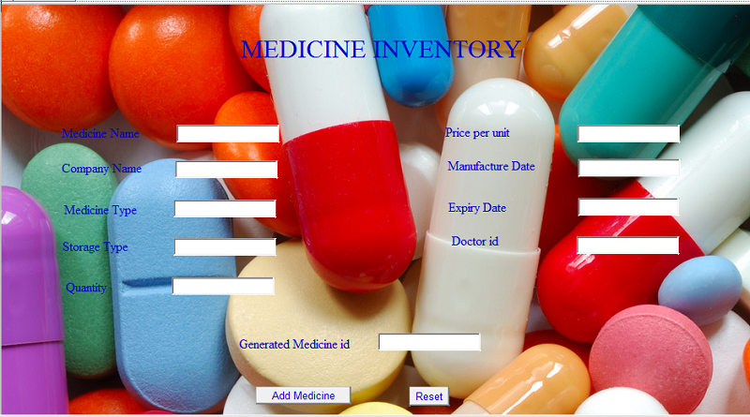

UI CONTROLS

|  |  |  |  |  |
| --- | --- | --- | --- | --- |
| **#** | **UI Component** | **Type** | **Name** | **Details** |
| 1 | Medicine name | Label | lbl_med_name |  |
| 2 | Medicine Name | Textbox | txt_med_name | Gets the medicine name |
| 3 | Company name | label | lbl_com_name |  |
| 4 | Company name | textBox | txt_com_name | Gets the company age |
| 5 | Medicine type | label | lbl_med_type |  |
| 6 | Medicine type | textBox | Txt_med_type | Gets the medicine’s type |
| 7 | Storage type | label | lbl_stor_type |  |
| 8 | Storage type | textbox | Txt_stor_type | Gets the storage type |
| 9 | Quantity | label | lbl_quant |  |
| 10 | Quantity | textbox | txt_quant | Gets the quantity |
| 11 | Price per unit | label | lbl_price |  |
| 12 | Price per unit | textBox | txt_price | Gets the price per unit |
| 13 | Manufacture date | Label | lbl_man |  |
| 14 | Manufacture date | textBox | Txt_ Manufacture_date | Gets the date of manufacturing of medicine |
| 15 | Expiry date | Label | lbl_exp |  |
| 16 | Expiry date | Date time picker | dateTimePicker_exp | Gets the date of expiry of medicine |
| 17 | Doctor ID | Label | lbl_doctor_id |  |
| 18 | Doctor ID | textBox | txt_doctor_id | Gets doctor ID |
| 19 | Medicine Id | label | lbl_medicineid |  |
| 20 | Medicine Id | textbox | txt_medicineid | Display the medicine id generated |

UI METHODS

|  |  |  |
| --- | --- | --- |
| **Method Name** | **Parameter** | **Details** |
| ValidateName | Medicine Name | Check if the medicine name consists only alphabets and spaces . |
| ValidateComName | Company Name | Check if the company name consists only alphabets and spaces . |
| Binddata() | None | Binds the medicine  Id to Data_grid_view_med gridview |
| ValidateMandatory | None | Check all the not null columns are filled properly |

UI Event definition

|  |  |  |
| --- | --- | --- |
| **Event** | **Control/Component** | **Event Details** |
| On Load | Page | Load the types of medicine in the combobox |
| submitPresBtn_Click | submitPresButton | Adds the medicine details to the Database. |
| clearPresBtn_Click | clearPresButton | Clears medicine details from the page. |
| homePresBtn_Click | homePresButton | Reverts to the main home page |

Doctor Login Page

UI DESIGN

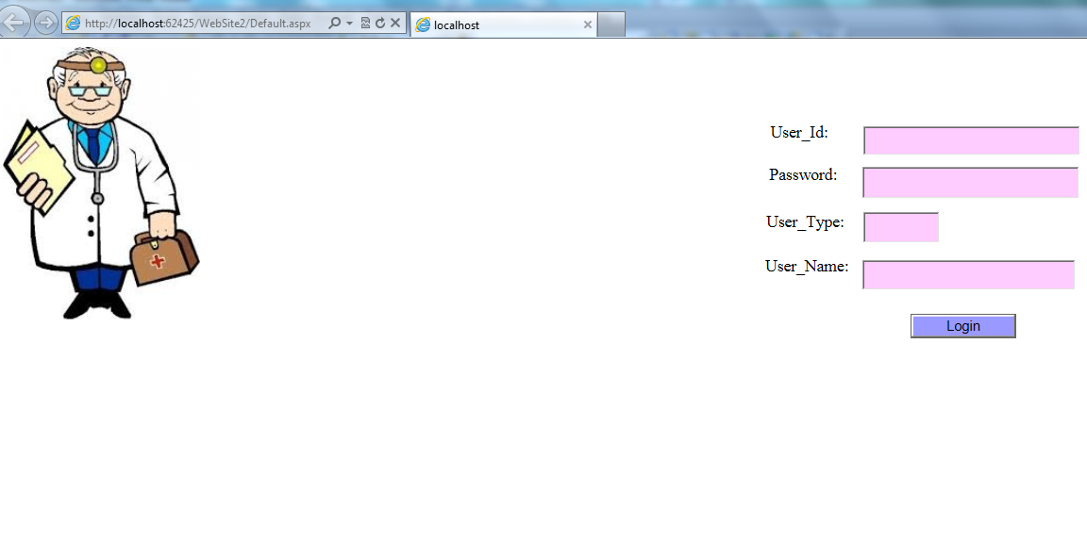

|  |  |  |  |  |
| --- | --- | --- | --- | --- |
| **#** | **UI Component** | **Type** | **Name** | **Details** |
| 1 | User ID | label | lbl_userid |  |
| 2 | User ID | TextBox | txt_userid | Gets doctor’s user id |
| 3 | Password | label | lbl_password |  |
| 4 | Password | TextBox | txt_password | Gets doctor password |
| 5 | User Type | label | lbl_usertype |  |
| 6 | User Type | TextBox | txt_usertype | Defaulted to Doctor |
| 8 | User Name | label | lbl_username |  |
| 9 | User Name | TextBox | txt_username | Gets doctor’s name |
| 10 | Login | label | lbl_login | Navigates to doctor’s prescription page |

Doctor Prescription Page

UI DESIGN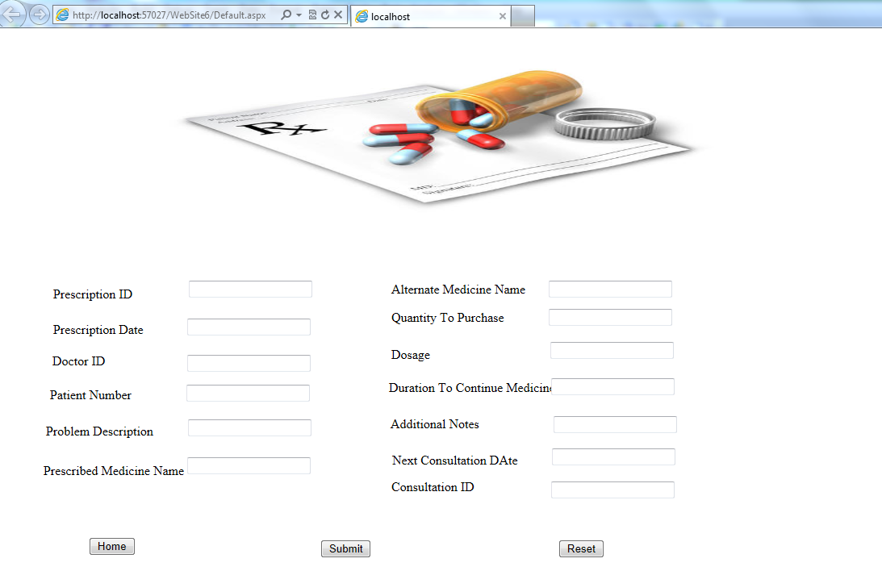

UI CONTROLS

|  |  |  |  |  |
| --- | --- | --- | --- | --- |
| **#** | **UI Component** | **Type** | **Name** | **Details** |
| 1 | Prescription Date | Label | lbl_pres |  |
| 2 | Prescription Date | Date time picker | Date_time_picker_pres | Get the date of the prescription added |
| 3 | Doctor id | Label | lbl_docId |  |
| 4 | Doctor id | Textbox | txt_docId | Gets the doctor id |
| 5 | Patient number | Label | lbl_pat_num |  |
| 6 | Patient number | Textbox | txt_pat_num | Gets the patient id |
| 7 | Problem description | Label | lbl_prob |  |
| 8 | Problem description | Textbox | txt_prob | Gets the description of the problem |
| 9 | Prescribed medicine name | Label | lbl_med_name |  |
| 10 | Prescribed medicine name | Textbox | txt_med_name | Gets the prescribed medicine name |
| 11 | Alternate medicine name | Label | lbl_a_med_name |  |
| 12 | Alternate medicine name | Textbox | txt_a_med_name | Gets the alternate medicine name |
| 13 | Quantity to purchase | Label | lbl_quant |  |
| 14 | Quantity to purchase | Textbox | txt_quant | Gets the quantity of the medicine |
| 15 | Dosage | Label | lbl_dose |  |
| 16 | Dosage | Textbox | txt_dose | Gets the dosage of the medicine |
| 17 | Duration | Label | lbl_dure |  |
| 18 | Duration | Textbox | txt_dure | Duration to continue the medicine |
| 19 | Additional notes | Label | lbl_add |  |
| 20 | Additional notes | Textbox | txt_add | Gets the additional notes from the doctor |
| 21 | Next consultation date | Label | lbl_con |  |
| 22 | Next consultation date | Date time picker | Date_time_picker_con | Get the date of the next consultation |
| 23 | Create prescription | Button | btn_pres | Add the prescription details |
| 24 | Reset | Button | Btn_reset | Clear the details |

UI METHODS

|  |  |  |
| --- | --- | --- |
| **Method Name** | **Parameter** | **Details** |
| ValidateDate | Prescription Date | Check if the prescription date is the current date. |
| Binddata() | None | Binds the prescription id and consultation ID to Data_grid_view_id gridview |
| ValidateMandatory | None | Check all the not null columns are filled properly |

UI Event definition

|  |  |  |
| --- | --- | --- |
| **Event** | **Control/Component** | **Event Details** |
| On Load | Page | Load the calendar for the dates |
| submitPresBtn_Click | submitPresButton | Adds the prescription details to the Database. |
| clearPresBtn_Click | clearPresButton | Clears Pres details from the page. |
| homePresBtn_Click | homePresButton | Reverts to the main home page |

Patient Login Page

UI DESIGN

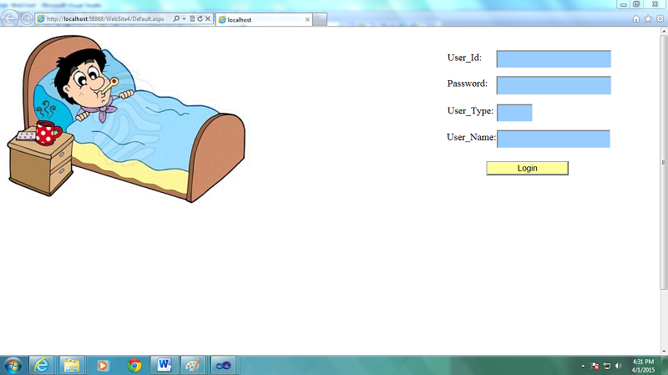

|  |  |  |  |  |
| --- | --- | --- | --- | --- |
| **#** | **UI Component** | **Type** | **Name** | **Details** |
| 1 | User ID | label | lbl_userid |  |
| 2 | User ID | TextBox | txt_userid | Gets Patient's user id |
| 3 | Password | label | lbl_password |  |
| 4 | Password | TextBox | txt_password | Gets Patient's password |
| 5 | User Type | label | lbl_usertype |  |
| 6 | User Type | TextBox | txt_usertype | Defaulted to Patient |
| 8 | User Name | label | lbl_username |  |
| 9 | User Name | TextBox | txt_username | Gets Patient's name |
| 10 | Login | label | lbl_login | Navigates to Patient's consultation history and feedback page |

New clerk registration page

UI DESIGN

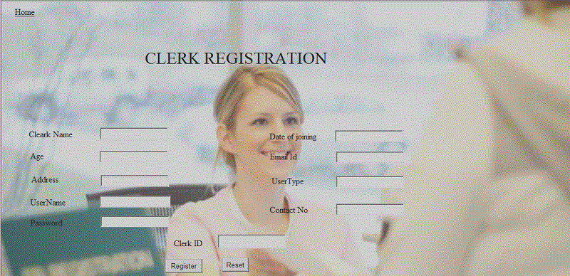

UI CONTROLS

|  |  |  |  |  |
| --- | --- | --- | --- | --- |
| **#** | **UI Component** | **Type** | **Name** | **Details** |
| 1 | Clerk Name | Label | lbl_name |  |
| 2 | Name | Textbox | txt_name | Gets the clerk name |
| 3 | Age | label | lbl_age |  |
| 4 | Age | Textbox | txt_age | Gets the age |
| 5 | Address | label | Lbl_address |  |
| 6 | Address | textBox | txt_Address | Gets the address of the clerk |
| 7 | country | label | lbl_Country |  |
| 8 | Email ID | label | lbl_EmailID |  |
| 9 | Email ID | textbox | txt_EmailID | Gets the email id of the clerk |
| 10 | Contact Number | label | lbl_Contact |  |
| 11 | Contact Number | textbox | txt_Contact | Gets the contact number of the clerk |
| 12 | User type | label | Lbl_usertype |  |
| 13 | User type | Combo box | comboBox_usertype | Default value ‘clerk’ |
| 14 | Date of joining | label | lbl_doj |  |
| 15 | Date of joining | Date Time Picker | dateTimePicker_doj | Date of joining to be entered by clerk |
| 16 | Register | button | btn_register | To submit the details of the clerk |
| 17 | Reset | button | btn_Reset | To clear all the fields |
| 18 | Clerk id | label | lbl_clerkid |  |
| 19 | Clerk id | textbox | txt_clerkid | To display the login details of clerk(clerkId and password) |

UI METHODS

|  |  |  |
| --- | --- | --- |
| **Method Name** | **Parameter** | **Details** |
| ValidateName | Name | Check if the name contains only alphabets and spaces. |
| ValidateContactNum | Contact Number | Check if the number is only numeric |
| ValidateEmailId | Email ID | Check if the format of id is correct or not |
| BindCountryName | None | Binds the country names to the combobox. |
| BindStateName | None | Binds the state names to the combobox |
| BindCityName | None | Binds the city names to the combobox |
| BindUsertype | None | Binds the user type to the combobox |
| Binddata() | None | Binds the clerk credentials to Data_grid_view_clerk gridview |
| ValidateMandatory | None | Check all the not null columns are filled properly |

UI Event definition

|  |  |  |
| --- | --- | --- |
| **Event** | **Control/Component** | **Event Details** |
| On Load | Page | Load the country, city, state, usertype values to the combobox |
| submitClerkBtn_Click | submitClerkButton | Adds clerk details to the Database. |
| clearClerkBtn_Click | clearClerkButton | Clears clerk details from the page. |
| homeClerkBtn_Click | homeClerkButton | Reverts to the main home page |

### Common Function

### Functional Requirement

This class contains methods which perform operations which are common to classes available in the employee management portal.

### Method Definition

|  |  |  |  |
| --- | --- | --- | --- |
| **Method Name** | **Parameter** | **Details** | **Return Type** |
| ExecuteDataSet | CommandType commandType, string commandText | Executes the SQL query and returns a dataset object. | DataSet |
| PrepareCommand | SqlCommand command, SqlConnection connection, SqlTransaction transaction, CommandType commandType, string commandText, SqlParameter[] commandParameters | Prepares the command object and sets the connection, commandtype, parameters to the command object. | void |
| AttachParameters | SqlCommand command, SqlParameter[] commandParameters | Sets the input parameters to the command object | void |
| ExecuteNonQuery | CommandType commandType, string commandText, params SqlParameter[] commandParameters | Sets the command type and name and the input parameters | Int |

# Database Design

## Data Model

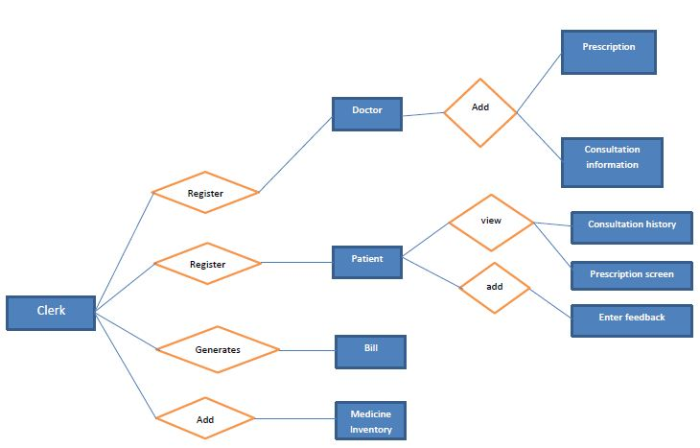

## Identification of Tables

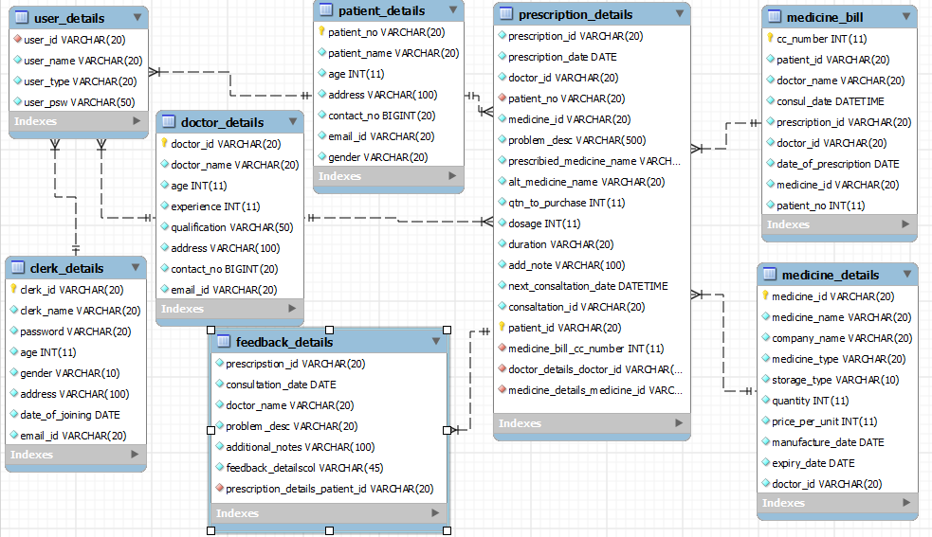

## Tables Structure

### Clerk Registration

|  |  |  |  |
| --- | --- | --- | --- |
| **Column****Name** | **Data Type** | **Length** | **Nulls** |
| Clerk_ID | varchar | 20 | N |
| Clerk_Name | varchar | 20 | N |
| Password | Varchar | 20 | N |
| Age | Int |  | N |
| Gender | Varchar | 10 | N |
| Address | varchar | 100 | N |
| Date_of_Joining | date |  | N |
| Email_id | varchar | 20 | N |

### Doctor Registration

|  |  |  |  |
| --- | --- | --- | --- |
| **Column Name** | **Data Type** | **Length** | **Nulls** |
| Doctor_ID | varchar | 20 | N |
| Doctor Name | varchar | 20 | N |
| Age | Int |  | N |
| Qualification | Varchar | 50 | N |
| Experience | varchar | 20 | N |
| Address | Varchar | 100 | N |
| Contact_no | Bigint |  | N |
| Email_Id | Varchar | 20 | N |

### Patient Registration

|  |  |  |  |
| --- | --- | --- | --- |
| **Column Name** | **Data Type** | **Length** | **Nulls** |
| Doctor_ID | varchar | 20 | N |
| Doctor Name | varchar | 20 | N |
| Age | Int |  | N |
| Qualification | Varchar | 50 | N |
| Experience | varchar | 20 | N |
| Address | Varchar | 100 | N |
| Contact_no | Bigint |  | N |
| Email_Id | Varchar | 20 | N |

### Add Medicine

|  |  |  |  |
| --- | --- | --- | --- |
| Column Name | **Data Type** | **Length** | **Nulls** |
| Medicine Name | varchar | 20 | N |
| Company_Name | varchar | 20 | N |
| Medicine_Type | varchar | 20 | N |
| Storage_Type | varchar | 20 | N |
| Quantity | int |  | N |
| Price_per_unit | int |  | N |
| Manufacture_Date | date |  | N |
| Expiry_Date | date |  | N |
| Doctor_ID | varchar | 20 | N |
| Medicine_ID | varchar | 20 | N |

### Feedback Details

|  |  |  |  |
| --- | --- | --- | --- |
| **Column Name** | **Data Type** | **Length** | **Nulls** |
| Prescription_id | varchar | 20 | N |
| Consultation_date | Date |  | N |
| Doctor_name | varchar | 20 | N |
| Problem_description | varchar | 100 | N |
| Add_notes | varchar | 100 | N |

### Prescription Details

|  |  |  |  |
| --- | --- | --- | --- |
| **Column Name** | **Data Type** | **Length** | **Nulls** |
| Prescription_id | Varchar | 20 | N |
| Prescription_date | Date |  | N |
| Doctor_id | varchar | 20 | N |
| Patient_id | Varchar | 20 | N |
| Medicine_id | varchar | 20 | N |
| Problem_description | varchar | 500 | N |
| Prescribed_medicine_name | Varchar | 20 | N |
| Alternative_medicine_name | varchar | 20 | N |
| Quantity_to_purchase | Int |  | N |
| Dosage | int |  | N |
| Duration | varchar | 20 | N |
| Additional_notes | varchar | 500 | N |
| Next_consultation_date | Date |  | N |
| Consultation_id | varchar | 20 | N |

## Objects Details

|  |  |  |
| --- | --- | --- |
| **Object Name** | **Object Type** | **Object Description** |
| AuthenticateClerk | Stored Procedure | Authenticates the logged in clerk against the database |
| AuthenticateDoctor | Stored  procedure | Authenticates the logged in Doctor  against the database |
| AddClerkDetails | Stored Procedure | Add the clerk Details to the database |
| AddDoctorDetails | Stored Procedure | Adds the doctor details to the database |
| AddPatientDetails | Stored Procedure | Adds the patient details to the database. |
| AddMedicineDetails | Stored Procedure | Adds the medicine details to the database. |

# Change Log

*Please note that this table needs to be maintained even if a Configuration Management tool is used.*

|  |  |  |  |  |  |
| --- | --- | --- | --- | --- | --- |
| Version Number | Changes made | | | | |
| V1.0 | *Document Creation* | | | | |
| V1.1 |  | | | | |
| Page no | Changed by | Effective date | | Changes effected |
|  |  |  | |  |
|  |  |  | |  |
|  |  |  | |  |
|  |  |  | |  |
| V1.2 | *<If the change details are not explicitly documented in the table below, reference should be provided here>* | | | | |
| Page no | Changed by | Effective date | Changes effected | |
|  |  |  |  | |
|  |  |  |  | |
|  |  |  |  | |
|  |  |  |  | |